Dokumentasi Final Assignment Web Programming

2602190085 – Hardi Kusuma

ConnectFriend

Application flow:

1. The application will display a home page containing photos from other users who have registered, according to the theme. If the theme is Casual then it contains pictures of users showing their hobbies, if the theme is Job, then display users who show their profession and field of work.

1. If the user selects one of the users in the image, direct the user to login if not already logged in. If the user has not registered, then create a register button that can be seen clearly on the login page.

1. Users can press the Thumb button to enter the desired user into the Wishlist.

1. If other users respond by pressing the Thumb button too then users can communicate with each other through the application (chat / video call (choose one)).

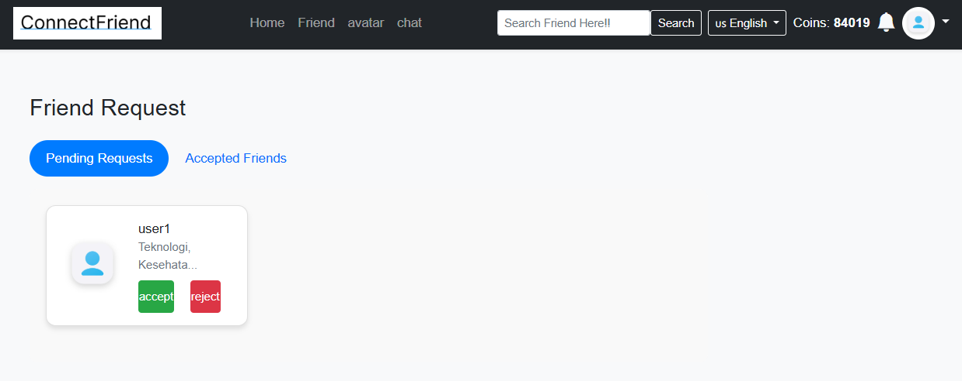

1. Users can filter users by gender. Create a container (page/section) for the gender filter.

1. Users can search by hobby/field of work. Create a container (page/section) to filter hobbies/fields of work.

1. [LO1,LO2,LO3 & LO4, 20 points] User Authentication

• Implement the user authentication feature with login and registration

• Perform validation according to the above conditions

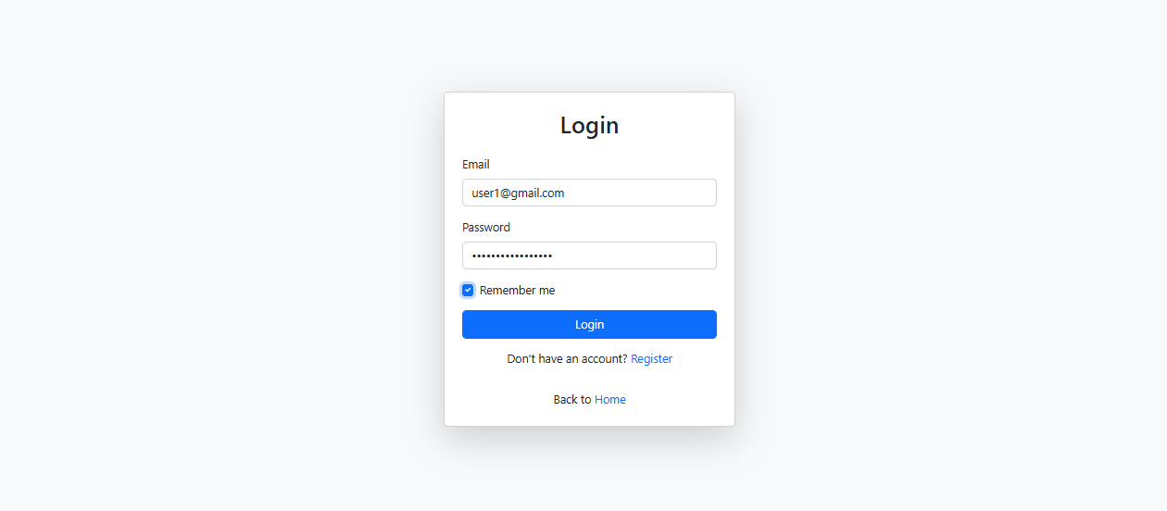

1. [LO1,LO2,LO3 & LO4, 10 points] Payment

• Every user who registers is required to make a payment.

• Payment using the Coin system

• Conduct validation in accordance with the provisions above

1. [LO1,LO2,LO3 & LO4, 30 points] Friends

• Implement the friends feature, allowing users to add and remove friends by giving likes according to the specified topic.

• Display the user's friend list on the profile

1. [LO1,LO2,LO3 & LO4, 20 points] Messaging/Video Call

• Each user who has made friends, can communicate with each other through messages/video calls

1. [LO1,LO2,LO3 & LO4, 10 points] Searching & Filtering

• Implement searching & filtering features to search/filter by gender. Or search/filter by hobby/job.

1. [LO1,LO2,LO3 & LO4,10 points] Notification

• Notify users of friend requests and incoming messages.

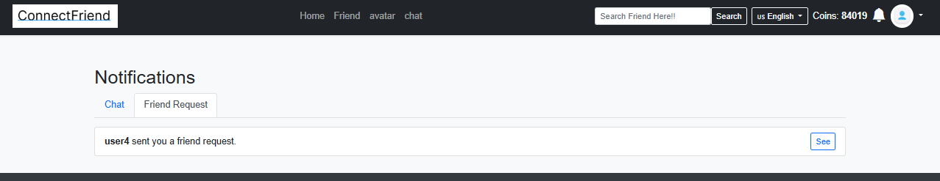

Additional Features :

1. [LO1,LO2,LO3 & LO4, 30 points] Buy Avatar

• Users can buy an avatar and use the avatar as a profile picture.

• The system must be able to deduct the total coins for each avatar purchase.

1. [LO1,LO2,LO3 & LO4, 15 points] Topup Coins

• User can add 100 coins from each press of 1 button.

1. [LO1,LO2,LO3 & LO4, 30 points] Visible Profile

